Venice High School
Medical Academy Application
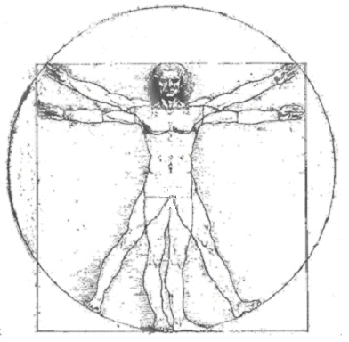

For information about the Medical Academy visit vhsma.com. Email completed application to carole.lash@sarasotacountyschools.net.

PLEASE NOTE: We can accept only a limited number of students.

Contact Information
Student’s Name: _____ ____________________________________________________________________

Address: ________________________________________________________________________________

Student’s email address: ___________________________________________________________________

Parent/Guardian name: ____________________________________________________________________

Parents’ daytime phone: ___________________________________________________________________

Parent email address: _____________________________________________________________________
Grade you will be in during the 2020-2021 school year: __________________________________________
Student Academic Information
If you attended a Sarasota County School last year this information can be found in the Student Portal. If you did not attend a school that administered the Florida State Assessments, please email documentation of your reading and math levels along with the application.
Most recent FSA Reading:
Level (1-5): ____________ Score (0-500): _________________
Most recent FSA Math:
Level: (1-5): ____________ Score (0-500): _________________
Fall Semester 2019-2020 Grades:
English/Language Arts Course Name: __________________________________ Grade ___________%
Math Course Name: ________________________________________________ Grade ___________%
Science Course Name: _______________________________________________ Grade ___________%

Student Reflections
What are your future medical career goals? __________________________________________________________________________________________________________________________________________________________________________________________________________________________________________________________________________________________________________________________________________________________________________________________________________________________________________________________________________________________________________________________________________________________________________________________________________________________________________________________________________________________________________________________________________________________________________________________________________________________________________________________________________________________________________________________________________________________________________________________________________________________________________________

Why are you interested in a career in medicine? __________________________________________________________________________________________________________________________________________________________________________________________________________________________________________________________________________________________________________________________________________________________________________________________________________________________________________________________________________________________________________________________________________________________________________________________________________________________________________________________________________________________________________________________________________________________________________________________________________________________________________________________________________________________________________________________________________________________________________________________________________________________________________________

Is there any additional information or special circumstances that you would like to share with us?
__________________________________________________________________________________________________________________________________________________________________________________________________________________________________________________________________________________________________________________________________________________________________________________________________________________________________________________________________________________________________________________________________________________________________________________________________________________________________________________________________________________________________________________________________________________________________________________________________________________________________________________________________________________________________________________________________________________________________________________________________________________________________________________

